Network Services Framework v1.0

Status of This Document

This document provides information to the Grid community on the service interface between a requesting software agent and a provider software agent that offers and delivers a Network Service. It is intended to describe the processes and environment in which software agents interact to deliver the service(s). Representing applications or other networks, these agents may request certain services of other network agents. Distribution is unlimited.

Copyright Notice

Copyright © Open Grid Forum (2008-2010). All Rights Reserved.

Trademark

OGSA is a registered trademark and service mark of the Open Grid Forum.

Abstract

Version 1.0 of the Network Services Framework describes a framework to support the request and management of Network Services; it allows an application or network provider to request Network Services from other network providers. This framework incorporates the interface, agent and associated services. The Network Service Interface (NSI) is defined to be the set of protocols and parameters that are used between a software agent requesting a Network Service and the software agent providing that Network Service. This document and its partner Network Service recommendations make up the complete NSI specification.

Contents
1. Context and Overview 2
2. NSI framework 3
2.1 Network Services 3
2.2 The Network Service Interface 3
2.3 The Network Service Agent 4
2.3.1 The Network Resource Manager 5
2.4 NSI Sessions 5
2.5 NSI service extensibility 6
2.6 The NSI Service Plane 6
2.7 NSI communications models 7
3. The NSI Protocol 8
3.1 NSI Protocol overview 8
3.2 NSI Messages 9
3.3 NSI Service Definitions 9
3.4 Temporal aspects of NSI services 10
3.5 Trust and authentication in NSI 10
3.6 NSI Service Plane error handling 11
4. Representing network resources 12
4.1 Describing network topologies 12
4.2 Using Service Termination Points 14
4.2.1 Service Termination Point 14
4.2.2 Service Demarcation Point 15
4.3 Managing Connections with the Intra-Network Topology 16
5. Summary 17
6. Contributors 18
7. Glossary 18
8. Intellectual Property Statement 20
9. Disclaimer 20
10. Full Copyright Notice 20
11. References 20

Context and Overview

Over the last decade, global networks have begun delivering high performance transport services directly to applications that require performance levels or capabilities unavailable in conventional best-effort IP networks. The ability to create connections between a fixed set of ports worldwide, with specific, predictable, and often demanding performance characteristics, enables emerging global collaborations to establish well-defined and highly customized network environments to support the end users and their applications. This has been particularly true within the Research and Higher Education space and the growing Grid community.

Connections across these transport networks have been historically reserved and provisioned in a variety of ways. The most common approach is manual provisioning – typically performed by a network engineer. More recently, some networking communities have developed tools and protocols to automate the process of network resource allocation and to allow the user or application to participate directly in the path creation process. These new approaches to automating transport connection provisioning are the basis for the standardization effort being described in this recommendation.

Automated connection-oriented transport provisioning capabilities are currently being deployed by Research & Education (R&E) providers as well as by commercial providers, and could eventually be implemented in home/ retail networks as deployment progresses. These automated provisioning systems, while being developed independently by different groups, all have common elements. They have developed software based control and/or management agents to regulate access to these resources, to schedule and reserve resources, to trigger or control timely provisioning of the network resources, and to monitor and release resources. These controllers are deployed in two different contexts. One context is application (or Grid) centric, where a network provides a resource to an application or middleware. The other context is network centric, where network resources are collaboratively shared among networks to expand or improve network performance or reach. In the former context, a user or application agent is requesting the service of a network provider. In the latter context, one network is interacting with other network(s) to manage these resources and deliver a comprehensive and well integrated service portfolio to the user community. This informational document defines a framework for the NSI protocol to support both of these contexts.

The Network Services Framework (NSF) defines several key architectural elements: the Network Service Interface (NSI), the NSI Protocol, the Network Service Agent (NSA), the Network Services, and the Inter-Network Topology. These elements exist in a notional Network Service Plane. The framework describes an environment within which network objects are defined as manageable resources. Within the framework, these network resources can be selected, allocated, interrogated, and manipulated by software agents on behalf of requesting users.

Federated Network Services are delivered by combining the capabilities of participating providers. To manage federated services, a range of network related functional capabilities such as topology sharing, path finding, resource reservation, hardware provisioning, and other ancillary services and functions are required.

The NSI protocol is defined by a suite of documents. This informational document describes the NSI Framework version 1.0. In addition, each Network Service is defined in its own architecture GFD.

NSI framework
This section discusses the architectural concepts that provide the Network Service context and high-level definitions for NSI protocol recommendations.

Network Services

Network Services allow applications to monitor, control, interrogate and support the network resources that are made available by the provider of the network. Typical transport network resources include a range of technologies such as wavelengths delivered using ROADMs, TDM on cross-connect equipment or packet switches. The NSI framework is designed to deliver a wide range of Network Services using all of these technologies.

An example of a Network Service is the Connection Service; this service is used to request and manage transport connections. Another example is the topology service; this is used to exchange network topologies.

Service requests may originate from an application, from grid middleware or from a network provider. A service can be requested by any application that has implemented an agent with a Network Service Interface. Similarly, the request can be serviced by any network provider who has implemented an agent with a NSI protocol interface.

Each service has an associated Service Definition (SD), this SD sets the scope of the service and identifies any parameter that is needed for the request to be fulfilled.

The NSI protocol deals with an abstracted model of transport services. This abstract concept is a simplified and convenient means of presenting the key functional aspects of the service object while hiding most or all of technical details and real-world complexities that are not relevant to the application. Similarly, the NSI protocol manages network resources by using an abstracted model of these resources. This model is called the Inter-Network model and its concepts are described in this framework document.

Each service is managed by an exchange of NSI Messages between agents. These messages operate using a set of service primitives. These service primitives are the set of instructions that allow the requester set up and manage a service. Each service request will result in the allocation of a service id for the new service instance.

In the remaining part of this section, the architectural components that make up the Network Services Framework are described.

The Network Service Interface

The Network Service Interface (NSI) provides secure and reliable sessions for service related communication between two NSAs. An instance of the NSI exists at the boundary between two communicating software agents: the Requester NSA and the Provider NSA. These agents interact to realize the delivery of a Network Service intrinsic to the network infrastructure. In this model, the Requester NSA requests some service, and the Provider NSA delivers it (see Figure 1).

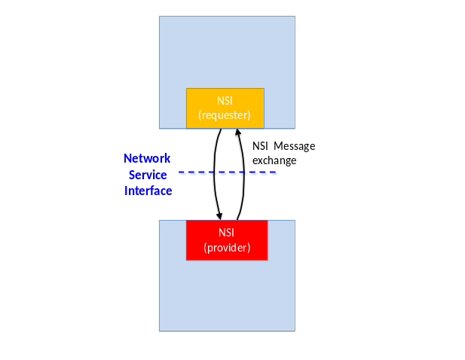
Figure 1: Network Service Interface

The Network Service Agent

The Network Service Agent (NSA) is a software entity that uses the Network Service Interface to request or provide Network Services. The NSA is central to the NSI architecture since all NSI processes are implemented within the Network Service Agent (NSA). An NSA can support different combinations of NSI Services. For example, each NSA shown in Figure 2 includes two types of Network Service; these are depicted as the green ‘Network Service’ boxes.

The NSA assumes three possible roles – Requester NSA, Provider NSA and Requester-Provider NSA. As a Requester, the NSA requests network resources and as a Provider it delivers these network resources to create a service. The Network Service Agent may at times act as a requester over one interface while acting as a provider at a different interface. This is the case in a Requester-Provider NSA acts as a gateway to other providers; in this role the NSA can forward requests to other Provider NSAs. Federations of networks are described further in section 2.7. These three modes of operation are depicted in Figure 2.

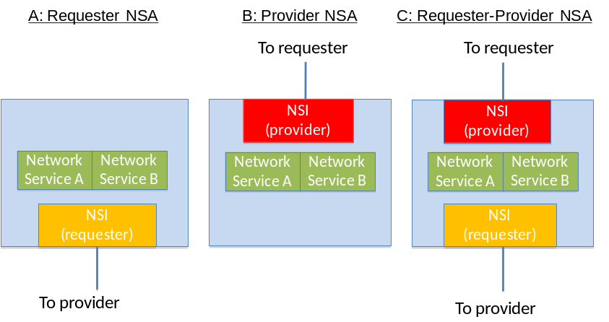
Figure 2: Network Service Agent modes

Also present in the Requester-Provider NSA, but not shown, are some additional peripheral functions such as the path-finding function or an NSA forwarding look up service. These supporting functions may be used to deliver Network Services and may be locally or remotely located. A description of these functions is out of scope of this document.

Each service type may support multiple simultaneous service instances; these instances are created in response to a service request and may be addressed by a unique service identifier. For example, a physical instance of a connection has its own Connection Service identifier.

The Network Resource Manager

The Provider NSA and Requester-Provider NSA may incorporate a Network Resource Manager (NRM). The NRM manages the part the Network Service implemented over local network resources; two examples of NSAs with NRMs are shown in Figure 3. The NRM has the ultimate authority for the local resources, this means that it can choose to accept or reject any request from the NSI for local resources.

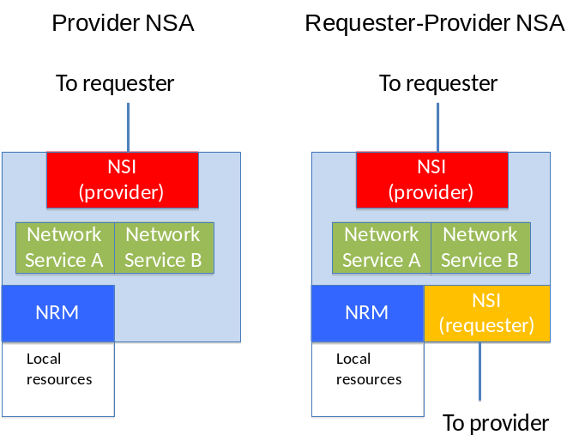
Figure 3: NRMs in an NSA

NSI Sessions

The NSI protocol creates a secure session between two NSA entities in the NSI requester and NSI provider role. Multiple service-to-service sessions can be multiplexed over the common NSA-to-NSA session. Each service-to-service session might establish their own security based on the credentials offered by the requesting service.

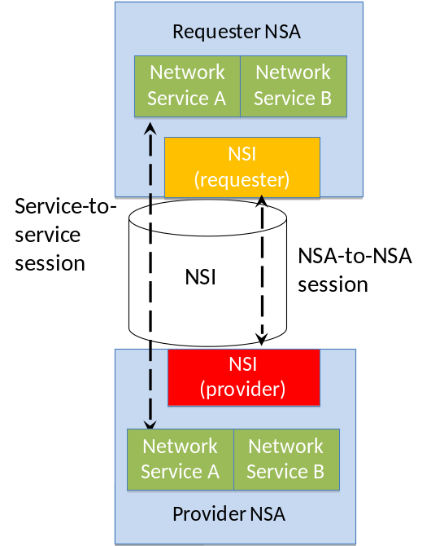
Figure 4: NSI sessions

NSI service extensibility

The Network Services Framework provides a common platform on which Network Services can be delivered. To achieve this aim, the NSI Architecture is extensible; it inherently supports the ability to add new Network Services as they emerge. Examples of anticipated services include a topology service to distribute topology information and a connection monitoring service to collect connection status or performance data. Network Service Agents must support these services and functions in order to provide an integrated service.

The NSI Service Plane

The NSI framework assigns the NSI to a notional Service Plane. Here we define the Service Plane as incorporating participating NSAs and the associated NSI sessions between these NSAs. The transport equipment (switches, X-connects etc) resides in the Transport Plane. This is depicted in Figure 5.

In general, the NSI Service Plane relies on the capabilities of the Control Plane and/or Management Plane to effect changes in the Transport Plane, where the Control and Management Planes follow conventional definitions. The transport resources and the physical instance of the Connection reside on the Transport Plane.

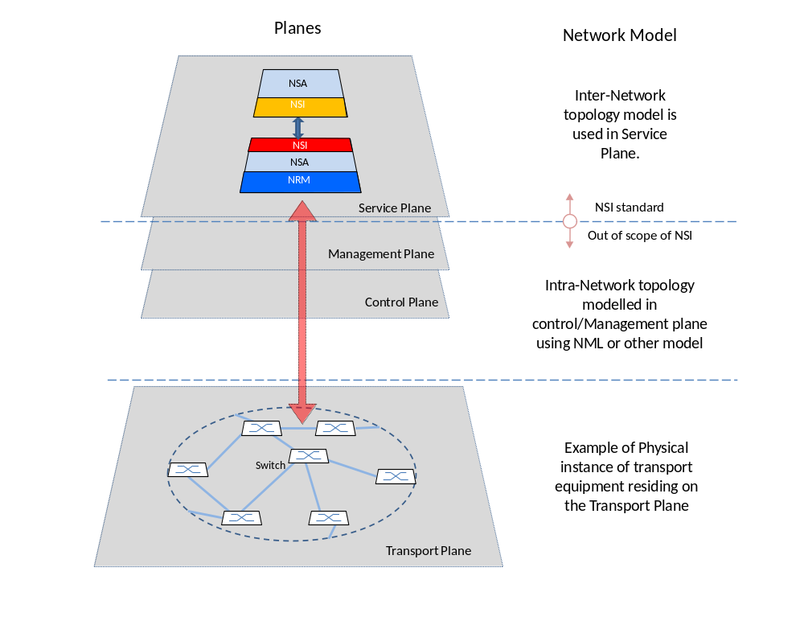

Figure 5: Transport Plane and Service Plane

The topology of the transport equipment is described on the Service plane using the Inter-Network model; details of this model are described in Section 4.

NSI communications models

The Network Services Framework is intended to allow services to be delivered across a chain of multiple participating networks. To facilitate this, flexible NSI Message forwarding is supported. This section describes the communications models supported for NSI Message handling.

No assumptions are made about the reachability of participating NSAs, an NSA may be directly reachable or reachable only via a third NSA. For instance, an arbitrary set of networks may band together under NSI rules and peer exclusively via a single Requester-Provider NSA. The Requester-Provider NSA may have no transport resources of its own – just those resources under management of the child NSAs. Service requests will flow along the trusted sessions hierarchically among NSAs. An example of this is shown in Figure 6 where NSA A communicates with NSA E via NSA B.

Figure 6 also shows NSA A operating as a gateway to multiple NSAs. In this case, NSA A behaves as a parent for both NSAs B and C. B in turn behaves as a parent for both NSAs D and E. As far as NSA A is concerned, NSA B appears as any other NSA even though it has two child NSAs.

Say NSA A receives a connection request and decides that should be implemented by B and C. To achieve this, the request is forwarded to these two NSAs. It is then up to B and C to decide if they wish to forward the requests further. C can deliver the resources locally, and B can forward the request on the D and E.
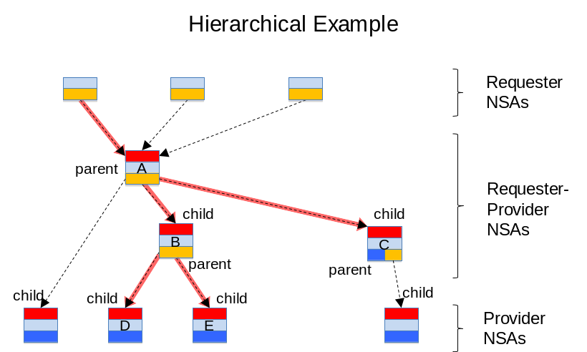

Figure 6: Tree communications model

It should be noted that in the case of highly meshed NSAs, a destination NSA may be reachable by more than one path. An example of this is shown in Figure 7. The NSI protocol places no constraints on how to forward NSI Messages. For example NSA A wishing to control a resource at E may choose to do this via intermediate NSAs B or C. However, it is a policy decision at NSA E as to whether it will accept a request from C or requires all requests to arrive via NSA B.
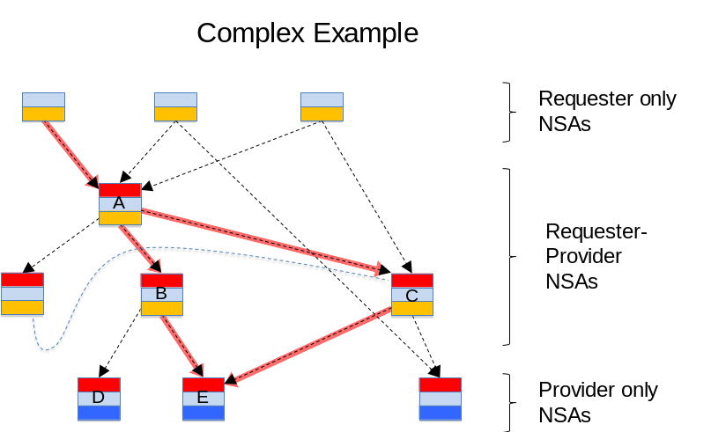

Figure 7: Complex communications model

The NSI Protocol

NSI Protocol overview

Network Services are delivered using the NSI Protocol, which defines the constructs, state machines, messages, and parameters associated with the NSI services model. This section provides an overview of the NSI Protocol concepts and constructs, while a detailed reference description of the protocol is available in the NSI Protocol Recommendation. In addition, each Network Service has its own informational document.

NSI Messages

The NSI protocol describes an exchange of NSI Messages between the requester and provider. Each NSI message includes a set of attributes, these message attributes are divided into 3 groups:
- Message common attributes
- Service attributes *
- Primitive attributes *

The base NSI protocol handler recognizes NSI Messages between NSAs. The protocol examines the message common attributes and forwards that message to the appropriate service specific handler. The service and its associated Service Definition define the full set of capabilities that are offered to requesters and the service instance defines one specific instance of the service.

Each Network Service type includes a set of service primitives. These primitives form a set of instructions that pass from the requester to the provider. In general, a service specific state machine is allocated and associated with each service instance, and the service primitives drive the transitions of that state machine.

Service instances are processed asynchronously with respect to other service instances. For example, one connection may transition from reserving, to scheduled, to in-service, to release at a vastly different speed than another connection established by the same service agent.

Each service instance has a locally unique identifier; this is used to maintain a message thread for that service instance. The thread also includes sequence numbering to ensure that ordering is maintained within the message thread.

NSI message common attributes
Message attributes includes the attributes that are common to all messages. This includes the NSI version, NSA addressing and security, the service that is being used and a transaction identifier. This is depicted as an UML entity relationship diagram below.

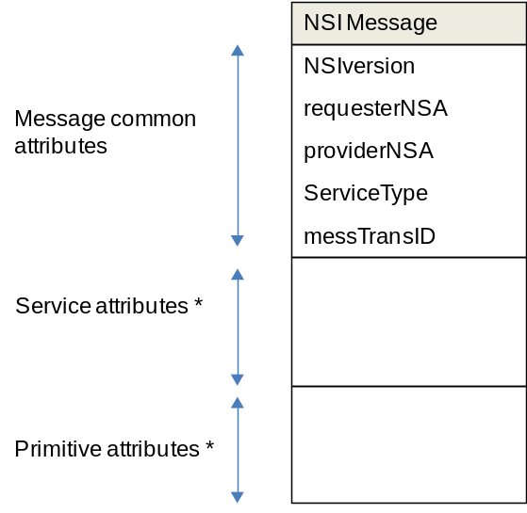

Figure 8: Attributes common to all messages

* For details of the Service and Primitive attributes please refer to the relevant Network Service definition GFD.

NSIversion
This message attribute identifies the NSI framework protocol version of the NSA that creates the message. This message attribute is included to allow new protocol versions to be released in future. In addition each service can have its own protocol version.

RequesterNSA
This message attribute identifies the requestor NSA sending a request or receiving a response to a request or receiving a notification. This message attribute also includes security parameters for the requester NSA.

ProviderNSA
This message attribute identifies the provider NSA receiving a request or sending a response to a request or sending a notification. This message attribute also includes security parameters for the provider NSA.

ServiceType
This message attribute identifies the service type, i.e. Connection Service, etc. being managed.

messTransID
This message attribute allows the requester NSA to match responses with requests where multiple responses are pending.

NSI Service Definitions

The concept of Service Definitions is introduced to allow network providers to formally identify and define the characteristics associated with each service offering.

The Service Definition consists of a set of attributes that formally and explicitly define the complete scope of a service offering. In particular, the NSI Connection Service uses the Service Definition as a baseline set of parameters to bound the scope of the service that will be offered to requesters.

The Service Definition specifies the set of service parameters that completely specify a service instance. For example, the Service Definition might identify “capacity”, “mtu_size”, and “maximum_frame_loss_rate” as three aspects of the service. The Service Definition also describes the range of allowed values for each service parameter, and a default value can be specified. In the context of the previous example, the range of allowed values for the “capacity” parameter may be 50 Mbps to 10 Gbps in increments of 150 Mbps. Or the “mtu_size” may be defined to be 1500 Bytes to 9000 Bytes with a default of 1500. The parameters in the Service Definition form a kind of template that the service request must fill in. I.e. a service request must fill in the template with explicit values for all parameters of the service without default values and optionally may provide values for parameters with the default values specified.

A service request is fully specified when all parameters associated with that service have been determined either by explicit user specification or by implicit default values found in the Service Definition. This fully specified request is then processed by the NSA and, if all service specifications can be satisfied, the service instance is reserved. (Note: a service instance identifier is created for each request- regardless of whether the request can ultimately be met. This allows the Provider Agent and the Requester Agent to process multiple requests asynchronously and in parallel and still be able to differentiate them.)

The Service Definition is an integral component of the NSI architecture in that it is key to vetting service requests against the multi-domain service offerings encountered along a candidate path.
The Service Definition is a public document that can serve as both a human readable guide to available service capabilities and a machine readable file that can be processed by automated agents in the NSI Architecture.

Temporal aspects of NSI services

Services, in which resources are dynamically requested, reserved and provisioned, require time information in a request to be interpreted in a common way. Any service that supports advance reservation must maintain its own real-time clock and it is necessary for the requester and provider clocks to be synchronized to a mutually acceptable granularity. In the case of a Connection Service, this granularity could be a fixed parameter of the Service Definition.

When a requester NSA seeks resources from a provider NSA, a service instance is created and an identifier is assigned to that service instance. Then, according to the parameters of the request (i.e. its Service Definition), the provider NSA identifies and reserves a set of available resources that satisfy the request and associates them to the instance. The resources are provisioned and released at some point on the temporal axis. The time information and signaling are used to specify the time boundary of the requested connection in-service period. It is the responsibility of the Provider NSA to attempt to deliver the resource as close to the start and end times as it is able. It should be noted that this may have some uncertainty as typically the duration of the provisioning phase cannot be precisely predicted.

Trust and authentication in NSI

This section describes the approach taken to trust and authentication in the NSI protocol; the detailed mechanisms for providing security and authentication are described in the NSI protocol recommendation.

Each NSA establishes NSI sessions with one or more other NSAs. An NSA will know for example that it is physically connected to its neighbor NSA; it may also have an identifier for that neighbor. Three types of trust are identified; types 1 and 2 are depicted in Figure 4 - NSA-NSA and service-to-service. Type 3 relates to trust beyond a Requester/Provider NSA pair.

1) NSA-to-NSA relationship: The Requester and Provider NSAs establish a secure session between Agents.

2) Service-to-service relationship: Secure sessions are established between the requester and provider parts of a Service. Standard methods for securing these sessions are described in the protocol document. These include:
- Relying on the NSA-to-NSA trusted session described in 1) above and
- Using separate ids and keys for the service-to-service trust.

3) Trust between non-adjacent NSAs: attributes included in an NSI Message must be trusted by the NSI Message receiver. When the sender and receiver are requester/provider NSAs this trust can rely on NSA-to-NSA trusted session. However, when an attribute received by an NSA is forwarded in an NSI Message to another NSA in the authorization sequence a mechanism to provide trust between such non-adjacent NSAs is required.

NSI Service Plane error handling

The Network Service Framework is based on a distributed, multi-agent architecture that is designed to handle error cases in such a way as to ensure predictable and deterministic behavior. This section describes the basis of error handling for this protocol.

Network Service errors can be broadly categorized as soft or hard failures. A soft failure occurs when two NSA agents lose communication with each other. A hard failure occurs if the NSA software restarts for any reason. Such failures may cause a loss of information about state information about services that were previously scheduled or are in process of being scheduled.

The NSI protocol incorporates mechanisms to recover to a consistent and predictable state after detecting an anomaly. The following architectural principles guide error handling and recovery:

- Handling of failures should result in deterministic behavior that is user centric and oriented towards the service model, for example: A failure in the Service Plane should not affect resources that are provisioned and active in the Transport Plane. A failure in the Service Plane should not result in an incomplete service.

- Recovery of Transport and/or Service Plane should not be reliant on external entities or mechanisms. For example: An NSA recovering from a hard failure error condition will not depend on peer NSAs to reconstruct its state. This does not prevent a query function to validate its own view with its peers.

- Failures in the Service Plane can result in NSA state faults. As depicted in Examples of Service Plane errors include: losing communication with an NSA, losing communication with the transport network, corruption/crash in the platform etc. These errors may result in service disruptions until these states can be synchronized, hence the NSI protocol and state machine design should account for such scenarios.

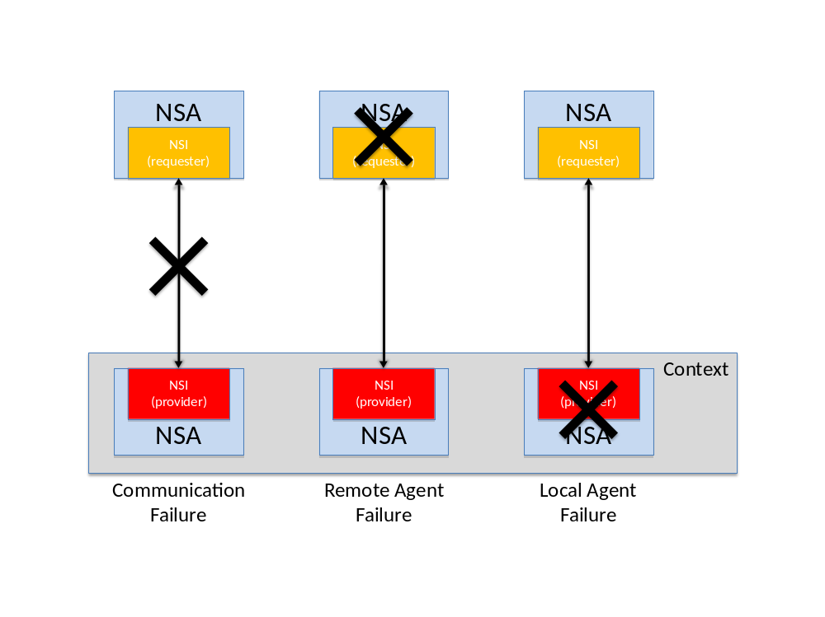
Figure 9: Local/Remote Failures within the context of a provider NSA

Regardless of where the error originates, it is important that the NSA recover to a deterministic state. This means that both the user service state and the resource state should be consistent between NSAs.

The distributed model of servicing user requests using the hierarchical model allows each NSA to assume the role of a requester or provider. When Service Plane failures occur, it is possible that an NSA will become entirely disconnected from other NSAs involved in a service instance. This scenario imposes a requirement on the NSA to have a linkage between its Requester and Provider Agent state machines to understand the impact of the failure on the service hierarchy and recover from it. The state machines should be designed so the outcome of a distributed failure ends each state machine in a deterministic state.

Representing network resources

Describing network topologies

A network transport topology is an object-oriented representation of network resources. The network topology may be used by functions such as path-finding and resource reservation.

For the purposes of the Network Services Framework, two topologies are identified; these are the Intra-Network and Inter-Network Topologies. Only the Inter-Network Topology is in-scope for the NSI protocol.

The Intra-Network Topology refers to the topology of the resources within a network, where a network is defined as the group of network resources managed by a single network provider and a single NSA. The network provider is expected to have a preexisting management or control system with its own method for network modeling. It is assumed that each NSA has access to its topology information, and no assumptions are made as to how this has been gathered or how it is represented. In other words, the method by which the Intra-Network Topology is represented is out-of-scope for the Network Service Framework. Many languages and models have been proposed to describe networks; some examples are OGF NML [1], and ITU-T G.805 [2], it is expected that these and others could be used.

The Inter-Network Topology refers to the topology of interconnected Networks. Here a Network is a topology object. The Inter-Network Topology is concerned with describing the way in which Networks are statically interconnected. It treats each Network as an aggregated set of Network capabilities with edge points. This Network Service Framework defines a representation of the Inter-Network Topology that should be used by the NSI. This is referred to as the Inter-Network Topology.

The Inter-Network Topology describes objects known as Service Termination Points (STPs) which identify the Edge Points on the Intra-Network Topology. These points represent resources (typically ports or virtual ports in the Intra-Network Topology), more than one STP can be associated with one Edge Point. A Network is a grouping of STPs that are available to an NSA. A Network also has a Transfer Function that defines the connectivity between STPs; this Transfer Function describes the aggregated transport capabilities internal to a Network. Users can request resources from a Network via its associated NSA.

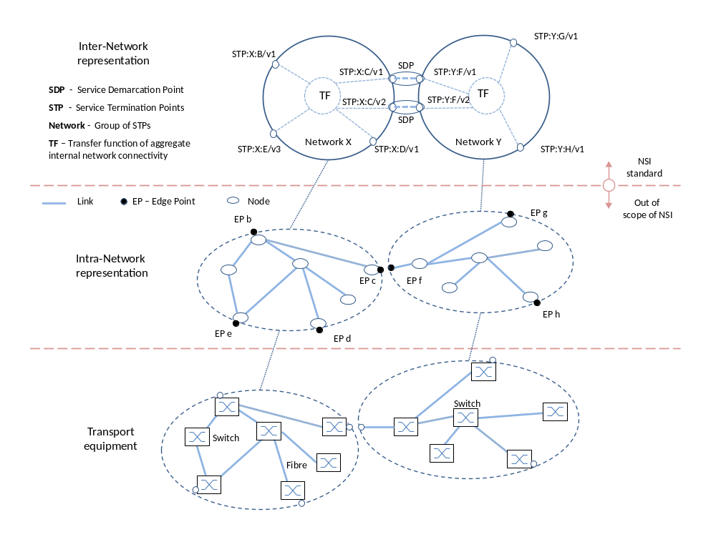
Figure 10: Inter-Network Topology

Each network provider can advertize a set of STPs to its local NSA. The NSA can then advertise these further to other NSAs. It is important to note that the provider advertises STP and the Transfer Function. These remain capabilities until they have been instantiated by the NRM via an instruction from the NSA. Details for using STPs are described in the next section.

Figure 10 depicts an example of an Inter-Network Topology. It shows an example of how Networks and STPs can be used to describe an aggregated representation of a conventional Network model such as OGF-NML.

As shown in Figure 10 more than one STP may be mapped to a single port in the Intra-Network Topology representation. This is shown as STP:Y:F/v1 and STP:Y:F/v2 both being VLANs and associated with port F. This is discussed in more detail in the next section.

The Inter-Network Topology as seen by a Requester-Provider NSA is aggregated and reported as an Intra-Network topology to parent NSAs.

By aggregating detailed transport topology into a single Network, or by grouping several Networks together to form a aggregated Network object, the global network topology may be reduced substantially. Successful implementation for a particular deployment will allow Pathfinders to inexpensively compute coarse-grained path(s) between any pair of Networks. Each NSA along the candidate path is then consulted to reserve and confirm the resources.

Note that it should not be assumed that a connection between Networks on the Transport Plane implies the existence of a NSI connection between associated NSAs. I.e the Transport Plane connectivity and Service Plane connectivity cannot be assumed to be congruent.

Using Service Termination Points

The NSI Architecture uses the concept of a Service Termination Points (STPs) and a pairing of STPs at a Service Demarcation Point (SDP). An STP names a topological location that is the ingress/egress point of a Network. For the purposes of the Connection Service, the demarcation point also forms the point at which Connections can be concatenated. This is the junction between the ingress of a Connection in one Network and the egress of a Connection in the next Network.

Service Termination Point

A prerequisite for an STP is the existence of a physical connection into a Network. This preexisting capability (typically made up of a physical port on a Network) can be advertised to an NSA. Note that the choice about which resources to advertize is subject to local policy. Once advertised, these capabilities may be used by the path-finding function of the NSA.

STPs are advertised as ‘capabilities’ to the NSA. I.e., they are not instantiated resources, but rather capabilities available for use in creating a Network Service. For example this would include advertising that a VLAN id 30 is available for use. When the NSA wishes to instantiate VLAN 30 this is signaled to the NRM and the VLAN 30 instance is created. Both STP capabilities and STP instances are represented in the Service Plane with STP ids.

An STP is a symbolic reference, i.e. it is an identifier which comprised of a parsable alphanumeric string containing two components: 1) a Network identifier string in the higher order portion, and 2) a local STP identifier in the lower order portion. An STP must always resolve to a specific topological port object as defined in the Intra-Network Topology representation. An STP is a conceptual entity that maps to specific resource in a network.

STPs may be uni or bi-directional. In the uni-directional case, the STP functions either as an ingress point or an egress point, this is defined by the flow polarity of the associated port, and which side of the junction is the user side, and which side is the network side.

An STP capability can be represented as a group of possible STP instances, or a more flexible representation like wildcard and constraints. For example, if there are 10 links these may be represented as a list (a,b, c, d, … j) or as a range (a-j). Note that this notation is used as an example only, please refer to the NSI protocol document for details.

A hierarchy of STPs may be represented using such groupings. For example an STP group A may contain 10 STPs (a-j). This can be represented as: A/a, A/b … A/j.

To support aggregation functions (Ethernet LAG or SDH virtual concatenation), two or more STPs can be aggregated. For example, if there are 10 links (1, 2, 3, …, 10) and any two of these links can be aggregated, in this example there are 90 possible STP instances (1-2, 1-3, …, 9-10). The use of hierarchical STP groups is important for aggregation since only STPs within a group can be aggregated.

Some examples are shown in Figure 11.

Service Demarcation Point

Two adjacent networks agree on the connectivity capability between the two networks. The process for this agreement is out-of-scope of the NSI. When two STPs in adjacent networks with matching capabilities are paired, the resulting pairing forms a Service Demarcation Point (SDP). Further, SDPs may be grouped; this is depicted in Figure 11.

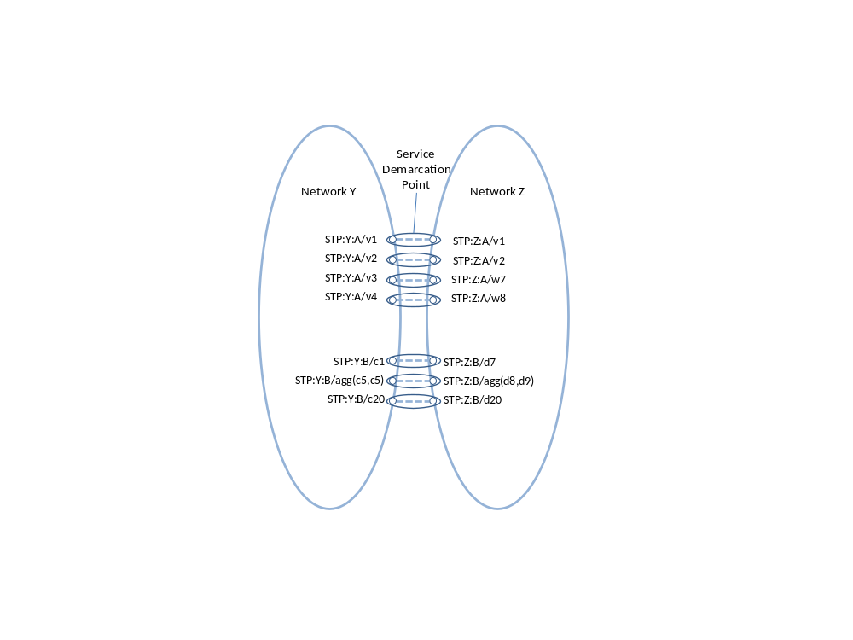
Figure 11: STP and SDP examples

Using the example shown in Figure 11, assume there are two Networks, Y and Z. The pairing process matches SDPs in each Network and then these are advertised as follows:
SDP A group:
(STP:Y:A/v1, STP:Z:A/v1)
(STP:Y:A/v2, STP:Z:A/v2)
(STP:Y:A/v3, STP:Z:A/w7)
(STP:Y:A/v4, STP:Z:A/w8)

SDP B group:
(STP:Y:B/c1, STP:Z:B/d7 )
(STP:Y:B/agg(c5,c9), STP:Z:B/agg(d8,d9))
(STP:Y:B/c20, STP:Z:B/d20)

It is important to note that the NSI Inter-Network Topology model is composed of Networks interconnected by pairs of STPs. It should be noted that this topology is neither a standard nor does it imply that an NSI implementation must adopt specifically any particular schema for its database in the code.

Managing Connections with the Intra-Network Topology

The Network Services Framework supports many services. The first of these is the Connection Service. The purpose of this service is to manage Connections. A Connection is defined to be the connectivity between STPs. Connections in two networks may be concatenated at Service Demarcation Points (STP pairs) to create longer Connections.

Once instantiated, an STP may have properties such as a framing, bandwidth and a VLAN id. Some of these properties may reflect the requirements specified in the Service Definition. Labeling (cf. fiber id, wavelength, VLAN id) and aggregation (cf. combining multiple switch ports) can be modeled as a property of an STP.

A Service Demarcation Point can function as both an ingress point on one side and an egress point on the other. Two such connections that share a single Service Demarcation Point in this way are said to be concatenated. These two concatenated connections then appear to the user payload as a single end-to-end transport plane data-path. In this way a Service Demarcation Point becomes intermediate transit-point of a path or connection, i.e a routing point through which the connection must pass.

Figure 12 depicts an example of a Connection Service between hosts, one internal to Network W and the other attached to an STP of Network Z. The Connection is created by requesting a Connection in Networks X, Y and Z. In Network W the Host is internally connected, (i.e not advertised to the NSA). In Network Z the host is connected to an STP it may be reached directly by using an NSI connection to STP k.

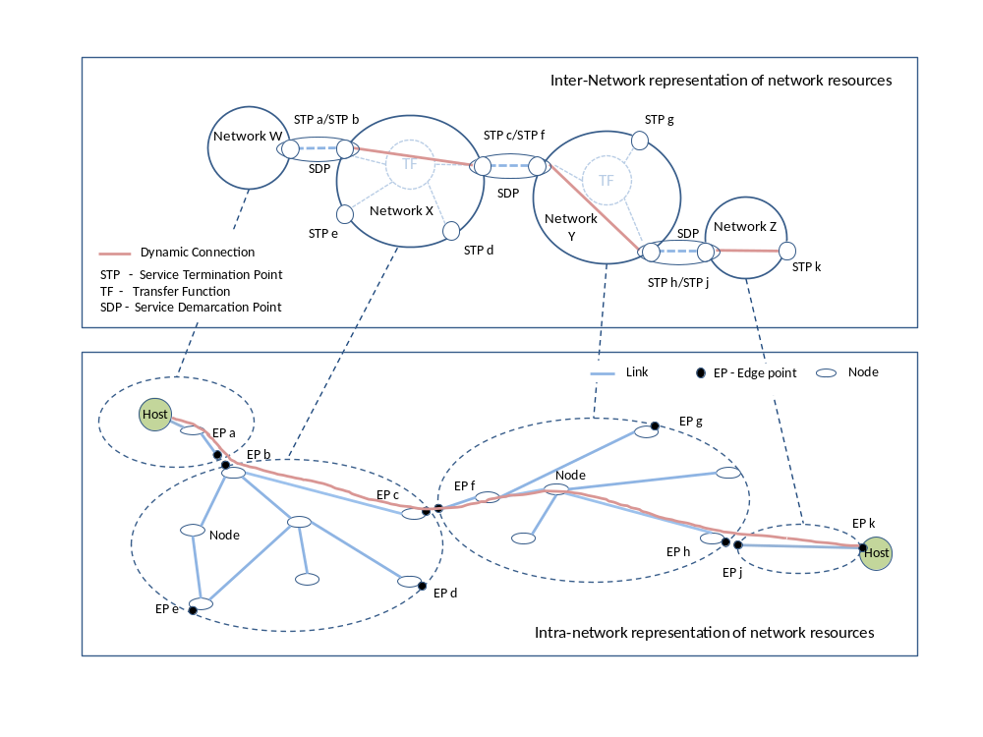
Figure 12: Representing Connections

Using the example in Figure 12, to request the shown Inter-Network connection, the NSA will request:
• To network X: instantiate a connection between STPs: X:b and X:c
• To network Y: instantiate a connection between STPs: Y:f and Y:h
• To network Z: instantiate a connection between STPs: Z:j and Z:k

Each NSA looks up its own calendar and checks availability of the STPs. Note that the NSAs for Networks X, Y and Z may have differing availability information in their local calendars.

Summary
The Network Services Framework defines several key architectural elements required to define and build services within the Network Service Plane. The framework describes an environment within which Network objects are defined as manageable resources. Within the framework, these network resources can be selected, allocated, interrogated, and manipulated by software agents on behalf of requesting users.
A suite of standards documents will define the NSI protocol. Those documents will implement the NSI Framework as described here. In addition, each Network Service, like a Connection Service, will be defined in its own recommendation document.
Federated Network Services are delivered by combining the capabilities of participating providers. To manage federated services, a range of network related functional capabilities such as topology sharing, path finding, resource reservation, hardware provisioning, and other ancillary services and functions are required. These may be formalized in future versions of the NSI protocol.

Contributors
Joan A. García-Espín, I2CAT
Chin Guok, ESNET
Radek Krzywania, PSNC
Tomohiro Kudoh, AIST
John MacAuley, Surfnet
Takahiro Miyamoto, KDDI R&D Laboratories
Inder Monga, ESnet
Guy Roberts, DANTE
Jerry Sobieski, NORDUNET
Sebastien Soudan, Laboratoire de l'Informatique du Parallèlisme
John Vollbrecht, Internet2
Freek Dijkstra, SARA
Jeroen van der Ham, University of Amsterdam

Glossary

Connection
A Connection is a conduit that transparently moves user information between STPs across a Network. A Connection has a set of properties (for instance, capacity, or authorization, or start time). These properties, and their allowed range of values, are defined by a Service Definition. A Connection instance on the Transport Plane is identified by a Connection Identifier exchanged on the Service Plane. Connections are unidirectional.

Connection Service
A Connection Service is a service that allows a Requester NSA to request and manage a Connection from a Provider NSA

Control and Management Planes
The Control Plane and/or Management Plane are not defined in this document, but follow common usage.

Edge Point
A network resource that resides at the boundary of an Intra-Network Topology, this may include for example a connector on a distribution frame, a port on an Ethernet switch, or a connector at the end of a fibre.

Inter-Network Topology
This is a topological description of a set of Networks and their transfer functions, and the connectivity between Networks.

Intra-Network Topology
This is a topological description that describes the connectivity internal to a Network. The level of detail that a provider chooses to advertise in the Intra-Network Topology is the choice of the provider.

Network
A Network is an Inter-Network topology object that describes a set of STPs with a Transfer Function between STPs.

Network Resource Manager (NRM)
The Network Resource Manager owns a set of transport resources and has ultimate responsibility for authorizing and managing the use of these resources. Each NRM is always associated with a single NSA.

Network Services
Network Services are the services offered by an NSA. Each NSA will support one or more Network Services.

Network Service Agent (NSA)
The Network Service Agent is a concrete piece of software that sends and receives NSI Messages. The NSA includes a set of capabilities that allow Network Services to be delivered.

Network Service Interface (NSI)
The NSI is the interface between Requester NSAs and Provider NSAs. The NSI defines a set of interactions or transactions between these NSAs to realize a Network Service.

Network Services Framework
The Network Services framework describes a NSI message based platform capable of supporting a range of Network Services.

NSI Message
A NSI Message is a structured unit of data sent between a Requester NSA and a Provider NSA.

Requester and Provider NSAs
An NSA acts in one of two possible roles relative to a particular instance of an NSI. When an NSA requests a service, it is called a Requester NSA. When an NSA realizes a service, it is called a Provider NSA. A particular NSA may act in different roles at different interfaces.

Service Definition
The Service Definition consists of a set of attributes that formally and explicitly define the complete scope of a service offering. Each provider defines its service with an SD, each request identifies requirements in terms of SD attributes, and each Connection has an associated Service Definition instance.

Service Demarcation Point (SDP)
Service Demarcation Points (SDPs) consist of a pair of STPs on adjacent Networks that are attached to each other.

Service Termination Point (STP)
Service Termination Points (STPs) identify the Edge Points in the Intra-Network Topology.

Service Plane
The Service Plane is a plane in which services are requested and managed; these services include the Network Service. The Service Plane contains a set of Network Service Agents communicating using Network Service Interfaces.

Transfer Function
The Transfer Function is a matrix that describes the transport capabilities between STPs.

Transport Plane
The Transport Plane contains is the set of transport equipment and associated resources that carry user data through the network.

Intellectual Property Statement

The OGF takes no position regarding the validity or scope of any intellectual property or other rights that might be claimed to pertain to the implementation or use of the technology described in this document or the extent to which any license under such rights might or might not be available; neither does it represent that it has made any effort to identify any such rights. Copies of claims of rights made available for publication and any assurances of licenses to be made available, or the result of an attempt made to obtain a general license or permission for the use of such proprietary rights by implementers or users of this specification can be obtained from the OGF Secretariat.

The OGF invites any interested party to bring to its attention any copyrights, patents or patent applications, or other proprietary rights which may cover technology that may be required to practice this recommendation. Please address the information to the OGF Executive Director.

Disclaimer
This document and the information contained herein is provided on an “As Is” basis and the OGF disclaims all warranties, express or implied, including but not limited to any warranty that the use of the information herein will not infringe any rights or any implied warranties of merchantability or fitness for a particular purpose.

Full Copyright Notice

Copyright (C) Open Grid Forum (2008-2010). All Rights Reserved.

This document and translations of it may be copied and furnished to others, and derivative works that comment on or otherwise explain it or assist in its implementation may be prepared, copied, published and distributed, in whole or in part, without restriction of any kind, provided that the above copyright notice and this paragraph are included on all such copies and derivative works. However, this document itself may not be modified in any way, such as by removing the copyright notice or references to the OGF or other organizations, except as needed for the purpose of developing Grid Recommendations in which case the procedures for copyrights defined in the OGF Document process must be followed, or as required to translate it into languages other than English.

The limited permissions granted above are perpetual and will not be revoked by the OGF or its successors or assignees.

References
[1] OGF, NML-WG: GFD-I.165: Network topology descriptions in hybrid networks
[2] ITU-T, G.805: Generic functional architecture of transport networks
[3] ITU-T G.8080/Y.1304: Architecture for the automatically switched optical network (ASON)

